ĐỀ THI TIẾNG ANH Mã đề: 03
Trình độ A2
Họ và tên thí sinh: ……………..……………………………………………………….…………………………………………………………
Số báo danh: ……………..…………………………………………...……. Phòng thi số: …………………………….……………

PAPER TWO LISTENING (Approximately 15 minutes)
PART 1: Questions 1 – 5
There are five questions in this part. For each question there are three answer choices and a short recording. Tick (√) the correct answer. You will hear the piece twice.
Example: How many people were at the meeting?
A. 3 B. 13 √ C. 30
1. When is the party?

A □ B □ C □
2. Where are the glasses?
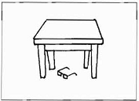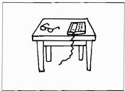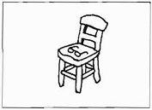
A □ B □ C □
3. How much are the shoes?
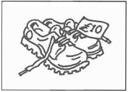 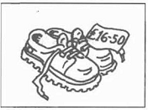  A □ B □ C □
4. What will the weather be like in the afternoon?
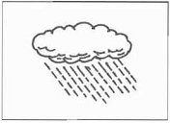  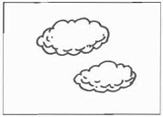 A □ B □ C □
5. What time will she take the train?
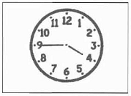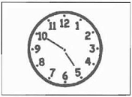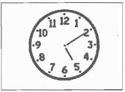
A □ B □ C □
4h45-A quarter by four 5h50(Ten by five 5h10- ten to five
PART 2: Questions 6-10
Listen to Patrick talking to his mother about a photo of his old school friends. What is each person wearing?
For questions 6-10, write a letter A-H next to each person. You will hear the conversation twice.

EXAMPLE | ANSWER
0 Peter | D
PEOPLE |  | THEIR CLOTHES
6 Martin  7 Joanna  8 Amy  9 James  10 Robert |  | A coat  B dress  C hat  D jacket  E jeans  F shirt  G sweater  H T-shirt

PART 3: Questions 11-15
Listen to Carlos asking for information about a library.
For questions 11-15, tick (√) A, B, or C. You will hear the conversation twice.
Example: 0. The library is closed until
A. Tuesday
B. Wednesday
√ C. Thursday
11. What must Carlos take to the library?
A. a student card
B. a teacher’s letter
C. a passport
12. How much will it cost Carlos to join?
A. 10 euros
B. 15 euros
C. 20 euros
13. Carlos will get
A. 2 library tickets
B. 3 library tickets
C. 4 library tickets
14. On Saturday, the library opens at
A. 10.30 a.m
B. 11.00 a.m
C. 2.30 p.m
15. The library is in
A. Murdoch Street
B. Murdosh Street
C. Murdock Sstreet

